Demonstrate the use of Calendar and Adrotator Control.

<%@ Page Language="C#" %>

<!DOCTYPE html PUBLIC "-//W3C//DTD XHTML 1.0 Transitional//EN" "http://www.w3.org/TR/xhtml1/DTD/xhtml1-transitional.dtd">

<script runat="server">

</script>

<html xmlns="http://www.w3.org/1999/xhtml">
<head runat="server">
<title></title>
</head>
<body>
<form id="form1" runat="server">
<div>

<asp:AdRotator ID="AdRotator1" runat="server"
AdvertisementFile="~/XMLFile.xml" />

</div>
</form>
</body>
</html>

.xml
<?xml version="1.0" encoding="utf-8" ?>
<Advertisements>
<Ad>
<ImageUrl>Nature.jpg</ImageUrl>
<AlternateText>Invalid</AlternateText>
<NavigateUrl></NavigateUrl>
</Ad>
<Ad>
<ImageUrl>waterfall.jpg</ImageUrl>
<AlternateText>Invalid</AlternateText>
<NavigateUrl></NavigateUrl>
</Ad>
</Advertisements>

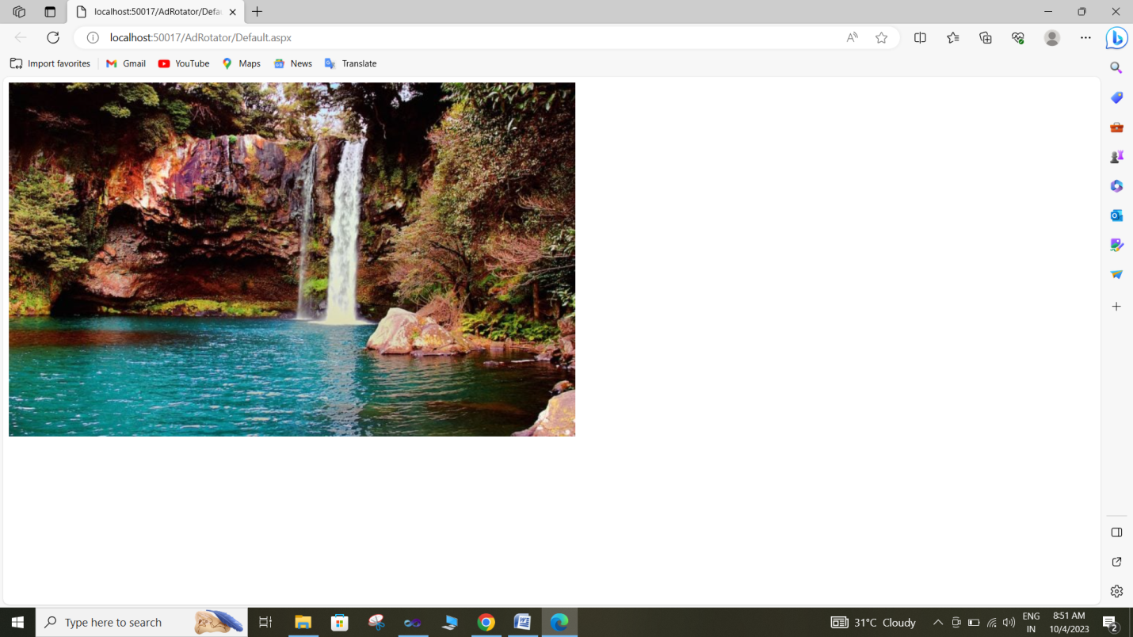

ASP .net program Demonstrate use of Master Page

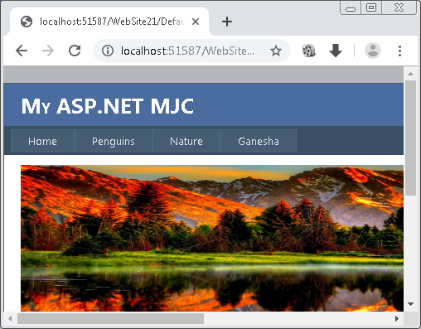

Demonstrate Properties of website navigation controls.

<%@ Page Language="C#" AutoEventWireup="true" CodeFile="Default.aspx.cs" Inherits="_Default" %>

<!DOCTYPE html PUBLIC "-//W3C//DTD XHTML 1.0 Transitional//EN" "http://www.w3.org/TR/xhtml1/DTD/xhtml1-transitional.dtd">

<html xmlns="http://www.w3.org/1999/xhtml">
<head runat="server">
<title></title>
</head>
<body style="font-size: large">
<form id="form1" runat="server">
<div>
&#39;Menu Control<br />
<asp:Menu ID="Menu1" runat="server" BackColor="#FFFBD6"
DynamicHorizontalOffset="2" Font-Names="Verdana" Font-Size="0.8em"
ForeColor="#990000" StaticSubMenuIndent="10px"
style="color: #0000FF; font-size: large">
<DynamicHoverStyle BackColor="#990000" ForeColor="White" />
<DynamicMenuItemStyle HorizontalPadding="5px" VerticalPadding="2px" />
<DynamicMenuStyle BackColor="#FFFBD6" />
<DynamicSelectedStyle BackColor="#FFCC66" />
<Items>
<asp:MenuItem NavigateUrl="~/Page1.aspx" Target="new" Text="Home" Value="Home">
</asp:MenuItem>
<asp:MenuItem NavigateUrl="~/Page2.aspx" Target="new" Text="About Us"
Value="About Us">
<asp:MenuItem NavigateUrl="~/Page3.aspx" Target="new" Text="Type" Value="Type">
</asp:MenuItem>
</asp:MenuItem>
<asp:MenuItem NavigateUrl="~/Page4.aspx" Target="new" Text="Contact"
Value="Contact"></asp:MenuItem>
<asp:MenuItem NavigateUrl="~/Page5.aspx" Target="new" Text="Feedback"
Value="Feedback"></asp:MenuItem>
</Items>
<StaticHoverStyle BackColor="#990000" ForeColor="White" />
<StaticMenuItemStyle HorizontalPadding="5px" VerticalPadding="2px" />
<StaticSelectedStyle BackColor="#FFCC66" />
</asp:Menu>

<br />
&nbsp;&nbsp;&nbsp;&nbsp; Tree View Control<br />

<asp:TreeView ID="TreeView1" runat="server">
<Nodes>
<asp:TreeNode NavigateUrl="~/Page1.aspx" Text="MJ College" Value="MJ College">
<asp:TreeNode Text="Arts" Value="Arts">
<asp:TreeNode Text="BA" Value="BA">
<asp:TreeNode Text="MA" Value="MA"></asp:TreeNode>
</asp:TreeNode>
</asp:TreeNode>
</asp:TreeNode>
<asp:TreeNode NavigateUrl="~/Page2.aspx" Text="Commerce" Value="Commerce">
<asp:TreeNode Text="BCOM" Value="BCOM">
<asp:TreeNode Text="BBA" Value="BBA">
<asp:TreeNode Text="MCOM" Value="MCOM"></asp:TreeNode>
</asp:TreeNode>
</asp:TreeNode>
</asp:TreeNode>
<asp:TreeNode NavigateUrl="~/Page3.aspx" Text="Science" Value="Science">
<asp:TreeNode Text="BSC" Value="BSC">
<asp:TreeNode Text="MSC" Value="MSC">
<asp:TreeNode Text="BCA" Value="BCA"></asp:TreeNode>
</asp:TreeNode>
</asp:TreeNode>
</asp:TreeNode>
</Nodes>
</asp:TreeView>
</div>
</form>
</body>
</html>

